

**Look forward to lots of summers to come**

I can help you focus on your financial present and your future too. With a cashflow model, we can look at how your spending, saving, and gifting - from small decisions to major outlays - could impact how much money you have later on.

If you have a family wedding   
coming up, you can make a gift   
of up to £3,000 tax-free.

A cashflow model can show   
the long-term impact of   
today’s spending.

Maximising your tax-free   
savings allowances now can   
help fund your future lifestyle.

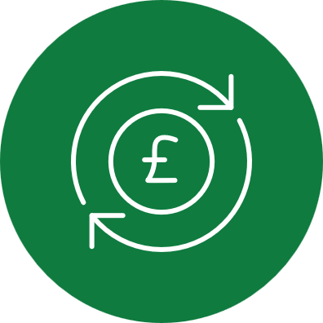

**Did you know?**

Hi [NAME]

Summer on the way means there can be lots to look forward to, like holidays, weddings and home improvements. But these kinds of things can come with hefty price tags. Thankfully, there are ways to spend wisely and save smartly so you can enjoy the moments that matter this summer with peace of mind about the ones to come too.

**Get in touch with me today**

If you’d like to discuss your options for living life to the full now and having the retirement lifestyle you want, you can find me at [***quilter.com/adviser-name***]

I look forward to hearing from you.

Kind regards,

[NAME]

Approver Quilter Financial Services Limited & Quilter Mortgage Planning Limited. March 2025.



**Enjoy the summer with financial peace of mind**

**Spend wisely and save smartly**